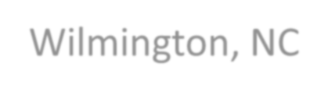
Flash Flood Watch continues through midnight
National Weather Service

Wilmington, NC

Prepared by:
Josh Weiss, Meteorologist

910
-
762
-
8724

Outlook Period:
Wednesday, July 25, 2018

Time Issued:
25
1000
AM, July

Overview: Tropical moisture tap will continue to bring scattered showers and thunderstorms into the area today and tonight. A decrease in heavy rainfall activity is expected beginning Thursday.

Impacts: Localized flooding is possible through tonight, especially across Cape Fear which has seen the most rain this week.

Timing/Confidence: Most of the heavy rainfall has ended this morning. Another round of showers with thunderstorms is possible late this afternoon and evening.
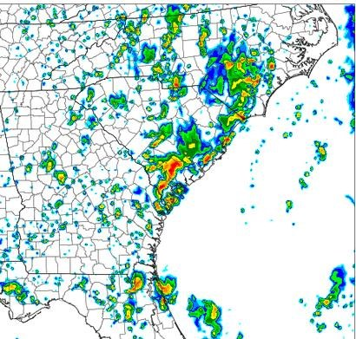
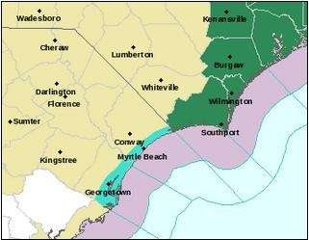
Possible radar at 5pm today from
NSSL WRF model

Flash Flood Watch remains in effect
until 12am Thursday for Cape Fear

For the latest updates, please visit our website and social media outlets:
www.weather.gov/ilm fb.com/nwswilmingtonnc @NWSWilmingtonNC

