2019 Annual Water Quality Report

|  |  |  |  |
| --- | --- | --- | --- |
|  | | | |
| C:\Users\awatters\Pictures\WWTP-and-WTP.jpg | | | |
|  |  | |  |
| In Case of Emergency For water main breaks or other emergencies, please contact us via our On Call phone number:  **910-471-1041** | DEAR Customer This report is a snapshot of last year’s water quality. Included are details about where your water comes from, what it contains, and how it compares to standards set by regulatory agencies. Our constant goal is to provide you with a safe and dependable supply of drinking water. We are committed to ensuring the quality of your water and to providing you with this information, because informed customers are our best allies. | | Pender County Utilities 605 E. Fremont St. P.O. Box 995 Burgaw, NC 28425 Phone: 910-259-1570 Fax: 910-259-1579  Law Enforcement Center  [www.pendercountync.gov](http://www.pendercountync.gov)  Copies of the CCR can be obtained from web site or the Utilities Office |
|  |  | |  |
|  | | What the EPA Wants you to know Environmental Protection Agency’s Safe Drinking Water Hotline  (800-426-4791) | |

Drinking water, including bottled water, may reasonably be expected to contain at least small amounts of some contaminants. The presence of contaminants does not necessarily indicate that water poses a health risk. More information about contaminants and potential health effects can be obtained by calling the Environmental Protection Agency's Safe Drinking Water Hotline (800-426-4791).

Some people may be more vulnerable to contaminants in drinking water than the general population. Immuno-compromised persons such as persons with cancer undergoing chemotherapy, persons who have undergone organ transplants, people with HIV/AIDS or other immune system disorders, some elderly, and infants can be particularly at risk from infections. These people should seek advice about drinking water from their health care providers. The Environmental Protection Agency (EPA) and Center for Disease Control (CDC) guidelines on appropriate means to lessen the risk of infection by *Cryptosporidium* and other microbiological contaminants are available from the Safe Drinking Water Hotline (800-426-4791).

The sources of drinking water (both tap water and bottled water) include rivers, lakes, streams, ponds, reservoirs, springs, and wells. As water travels over the surface of the land or through the ground, it dissolves naturally-occurring minerals and, in some cases, radioactive material, and can pick up substances resulting from the presence of animals or from human activity. Contaminants that may be present in source water include microbial contaminants, such as viruses and bacteria, which may come from sewage treatment plants, septic systems, agricultural livestock operations, and wildlife; inorganic contaminants, such as salts and metals, which can be naturally-occurring or result from urban storm water runoff, industrial or domestic wastewater discharges, oil and gas production, mining, or farming; pesticides and herbicides, which may come from a variety of sources such as agriculture, urban storm water runoff, and residential uses; organic chemical contaminants, including synthetic and volatile organic chemicals, which are by-products of industrial processes and petroleum production, and can also come from gas stations, urban storm water runoff, and septic systems; and radioactive contaminants, which can be naturally-occurring or be the result of oil and gas production and mining activities.

In order to ensure that tap water is safe to drink, EPA prescribes regulations which limit the amount of certain contaminants in water provided by public water systems. FDA regulations establish limits for contaminants in bottled water which must provide the same protection for public health.

**When You Turn on Your Tap, Consider the Source**

Pender County Utilities processes, treats, and distributes treated drinking water within Pender County through one primary system and two emergency connection systems. The primary source water that is then processed by the Pender County Utilities Surface Water Treatment Plant is surface water from the Cape Fear River purchased from the Lower Cape Fear Water and Sewer Authority. Additional emergency water supply is groundwater provided from the Pee Dee and Black Creek Aquifers purchased from the Town of Wallace (Ricky Raynor 910-285-2812) and the Town of Surf City (Jeanne King 910-328-4131). A staff of highly trained, state certified water treatment operators, a state certified Chemist, and a team of skilled maintenance technicians keep all the

facilities fully operational 24 hours per day, 7 days per week to ensure a safe, high quality, and reliable drinking water source.

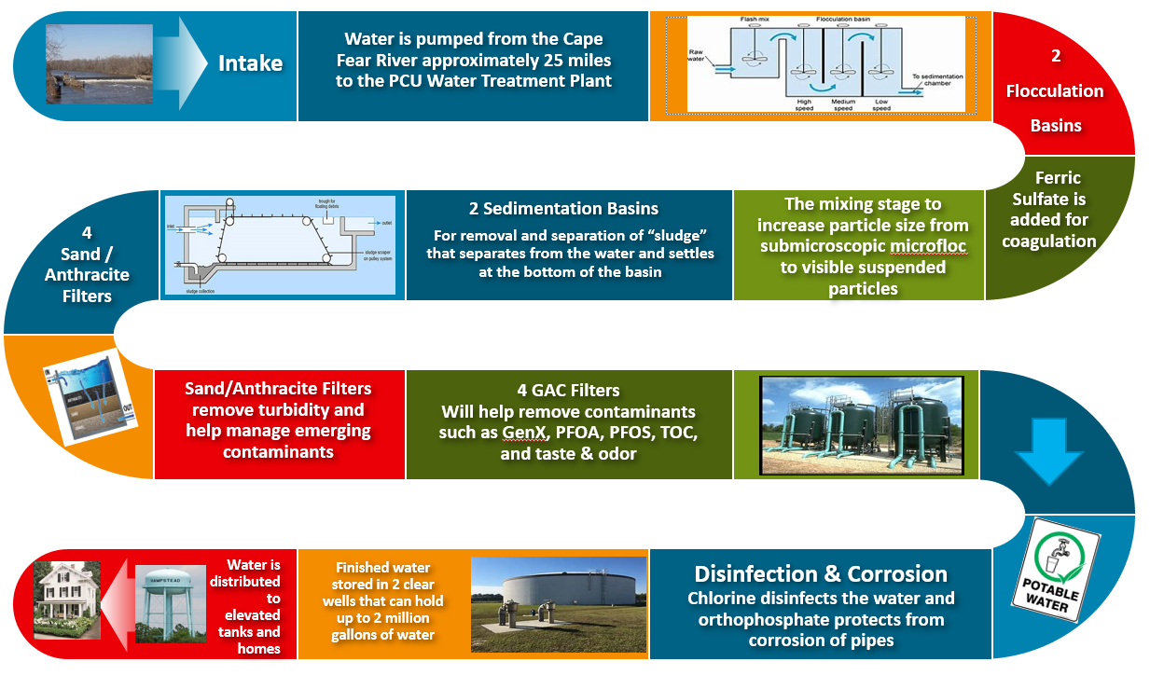

|  |  |
| --- | --- |
| C:\Users\awatters\Pictures\protect-our-water.jpg **Help Protect Your Source Water** Protection of drinking water is everyone’s responsibility. You can help protect your community’s drinking water source(s) in several ways:   * Disposal of fertilizers, pesticides, paints, and medications properly * Taking motor oil to a recycling center * Volunteering in your community to protect your drinking water source (Cape Fear River) |  |
| **Definition of Terms:** Non-Detects (ND) – Contaminant concentration below detectable limit  Action Level (AL) – The concentration of a contaminant which, if exceeded, triggers treatment or other requirements which a water system must follow.  Maximum Residual Disinfection Level Goal (MRDLG) – The level of a drinking water disinfectant below which there is no known or expected risk to health. MRDLGs do not reflect the benefits of the use of disinfectants to control microbial contaminants.  Maximum Residual Disinfection Level (MRDL) – The highest level of a disinfectant allowed in drinking water. There is convincing evidence that addition of disinfectant is necessary to control microbial contaminants.  Maximum Contaminant Level (MCL) – The highest level of a contaminant that is allowed in drinking water. MCLs are set as close to the MCLGs as feasible using the best available treatment technology.  Maximum Contaminant Level Goal (MCLG) – The level of a contaminant in drinking water below which there is no known or expected risk to health. MCLGs allow for a margin of safety.  Treatment Technique (TT) – A required process intended to reduce the level of a contaminant in drinking water.  ***A person would have to drink 2 liters of water every day at the MCL level for a lifetime to have a one-in-a-million chance of having the described health effect.*** |  |
|  |  |
| **Water Quality Data Table of Detected Contaminants**We routinely monitor for over 150 contaminants in your drinking water according to Federal and state laws. The table below list all the drinking water contaminants that we detected in the last round of sampling for the particular contaminant group. The presence of contaminants does not necessarily indicate that water poses a health risk. Unless otherwise noted, the data presented in this table is from testing done January 1 through December 31, 2019. The EPA or the State requires us to monitor for certain contaminants less than once per year because the concentrations of these contaminants are not exspected to vary significantly from year to year. Some of the data, through representative of the water quality, is more than one year old. Unregulated contaminants are those for which EPA has not established drinking water standards. The purpose of unregulated contaminant monitoring is to assist EPA in determining the occurrence of unregulated contaminants in drinking water and future regulations is warranted. | |

**Microbiological Contaminants:**



**Turbidity –** has no health effects. However, turbidity can interfere with disinfection and provide a medium for microbial growth. Turbidity may indicate the presence of disease-causing organisms. These organisms include bacteria, viruses, and parasites that can cause symptoms such as nausea, cramps, diarrhea, and associated headaches.



If present, elevated levels of lead can cause serious health problems if ingested over many years, especially for pregnant women and young children. Lead in drinking water is primarily from materials and components associated with private service lines and home plumbing and not the distribution mains or water supply. The Rocky Point/Topsail Water & Sewer District is responsible for providing high quality drinking water, but cannot control the variety of materials uses in plumbing components. Most sources of drinking water have no lead or very low levels of lead. Most lead gets into drinking water after the water leaves the local water well or treatment plant and comes into contact with plumbing materials containing lead with a home or business. When your water has been sitting for several hours, you can minimize the potential for lead exposure by flushing your tap for 30 seconds to 2 minutes before using water for drinking or cooking. Do not boil water to remove lead and identify if your plumbing fixtures contain lead. Information on lead in drinking water, testing methods, and steps you can take to minimize exposure is available at the office of Pender County Utilities or from the Safe Drinking Water Hotline at 1-800-426-4791 or at <http://www.epa.gov/safewater/lead>.

If more than 10% of tap water samples exceed the lead “action level”, Pender County Utilities is required to inform the site authorizing the sample about their water quality results, provide public education on lead to those sampling sites that participate in our lead tap monitoring program, continue monitoring for lead and copper; and document our efforts to the North Carolina Department of Environment and Natural Resources Division of Environmental Health.

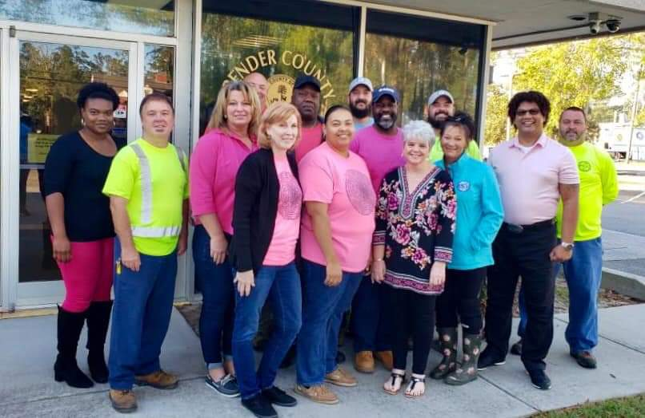 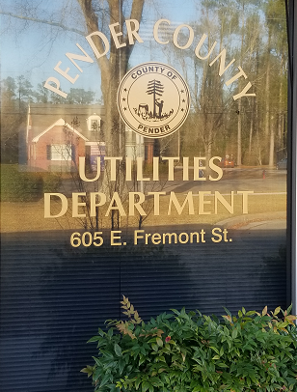 

**Lead and Copper Contaminates**



Some people who drink water containing trihalomethanes in excess of the MCL over many years may experience

problems with their liver, kidneys, or central nervous systems, and may have an increased risk of getting cancer.

**Disinfectants and Disinfection Byproducts Contaminants – Based on Locational Running Annual Average**







|  |  |  |  |  |
| --- | --- | --- | --- | --- |
| Unregulated Substance | EPA MCL | Amount Detected  (AVG) | Range  Low-High | Likely Source of Contamination |
| ** Perfluoro-2-propoxypropanocic acid (GenX) | Non Regulated | 41.53 ppt | 19 – 80 ppt | By-product of Chemical Manufacturer |

** The N.C. departments of Environmental Quality (DEQ) and Health and Human Services (DHHS) began investigating the presence of a compound known as GenX in the Cape Fear River in June 2017. The Chemours facility in Fayetteville was identified as the company that produces the GenX chemical for industrial processes.

The state’s investigation focused on protection of public health and drinking water. As part of the state’s investigation, DEQ began collecting water samples from multiple sites along the Cape Fear River, with additional samples collected throughout the region. Those samples were analyzed at two separate labs: Test America in Colorado and the Environmental Protection Agency’s lab in the Research Triangle Park.

Thanks to the state’s investigation, the release to the Cape Fear River of GenX and two other fluorinated compounds has stopped, water quality for these compounds at all finished drinking water sites is well within state health goals, and the state is developing better information needed to protect North Carolina’s water quality and public health.

Additional information about GenX may be found on the NCDEQ website at:

<https://deq.nc.gov/news/hot-topics/genx-investigation>

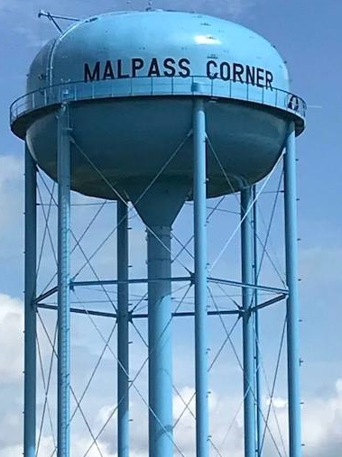

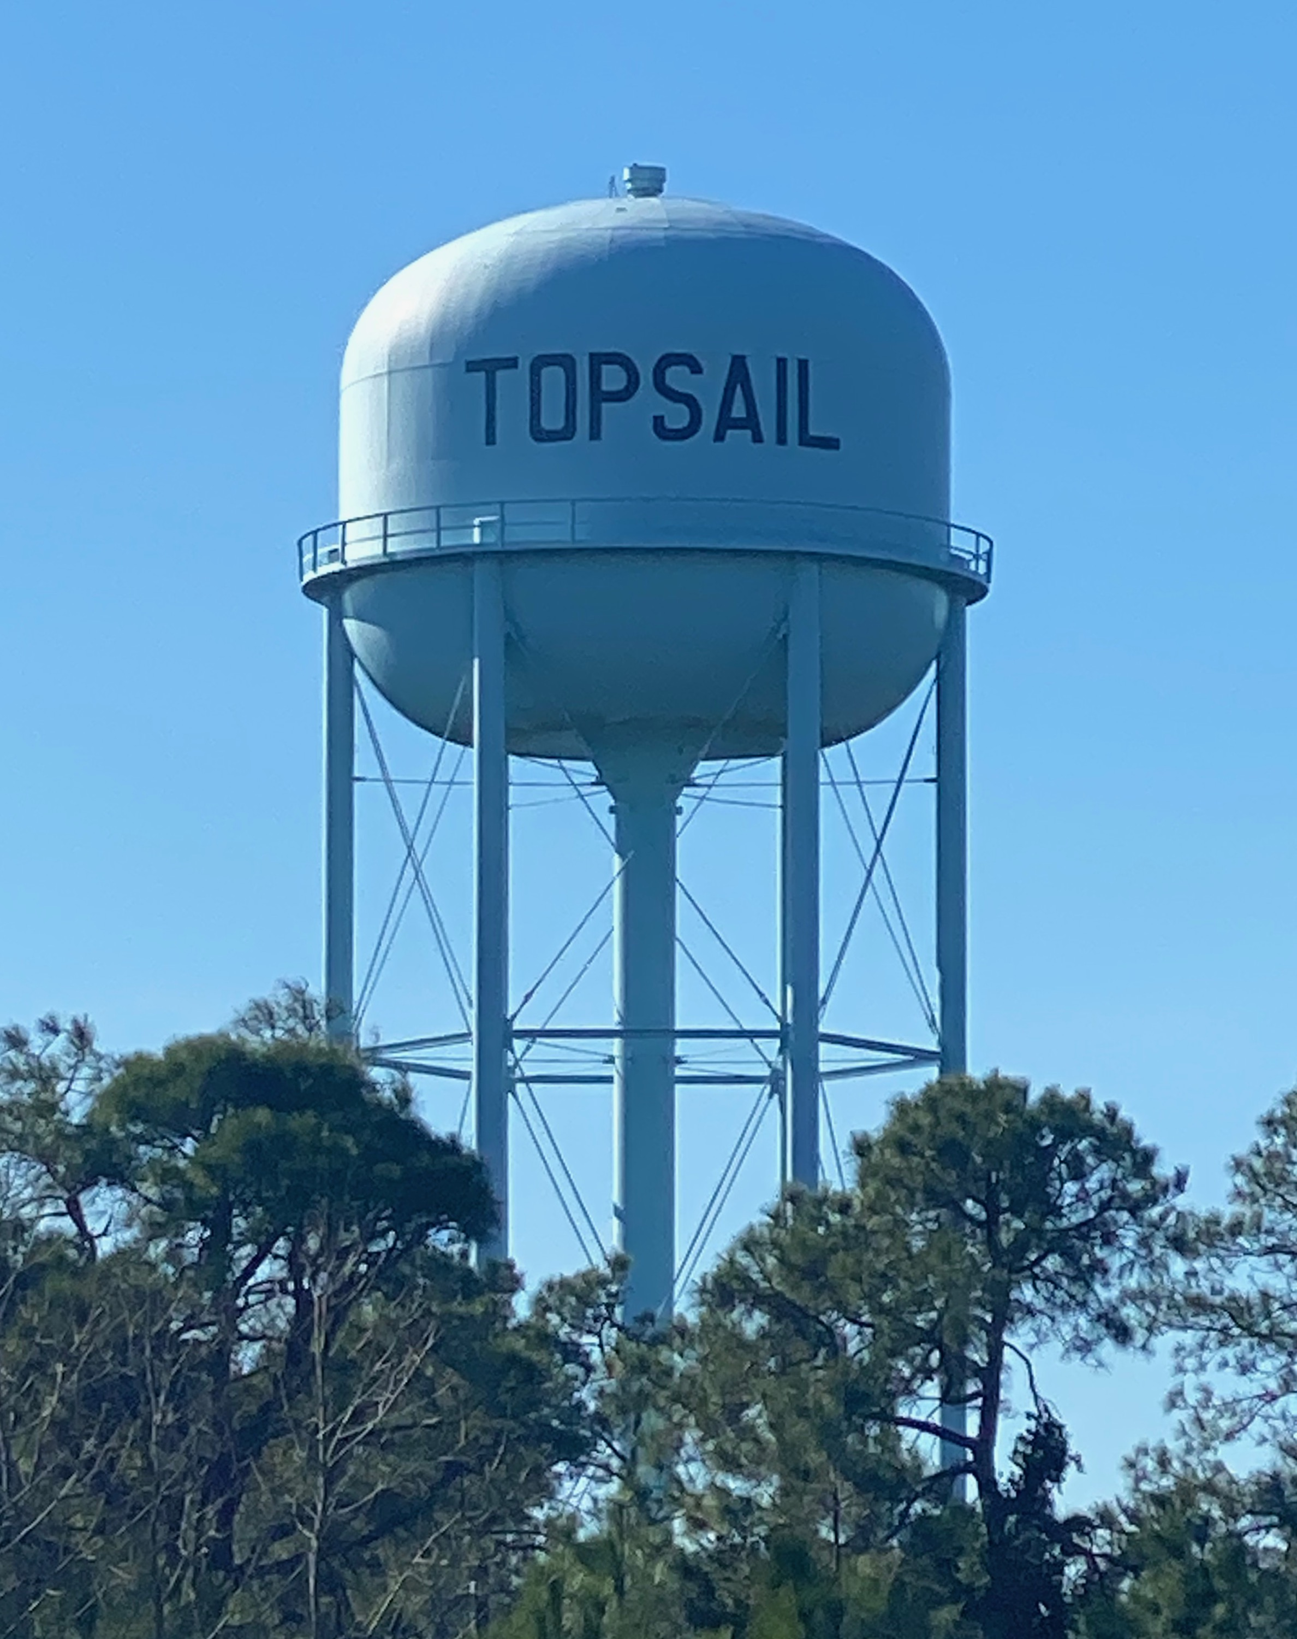

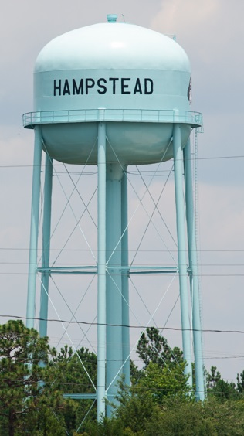

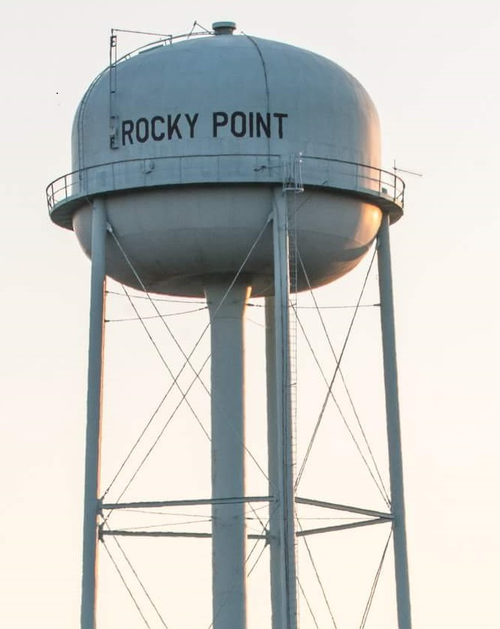

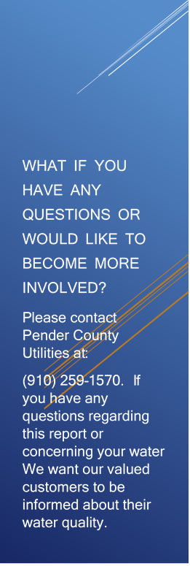

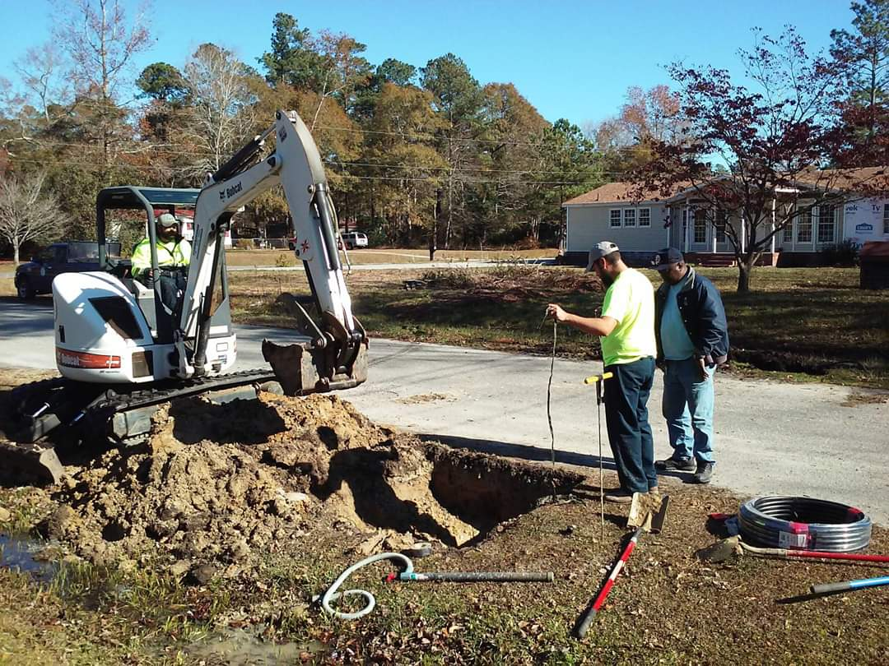

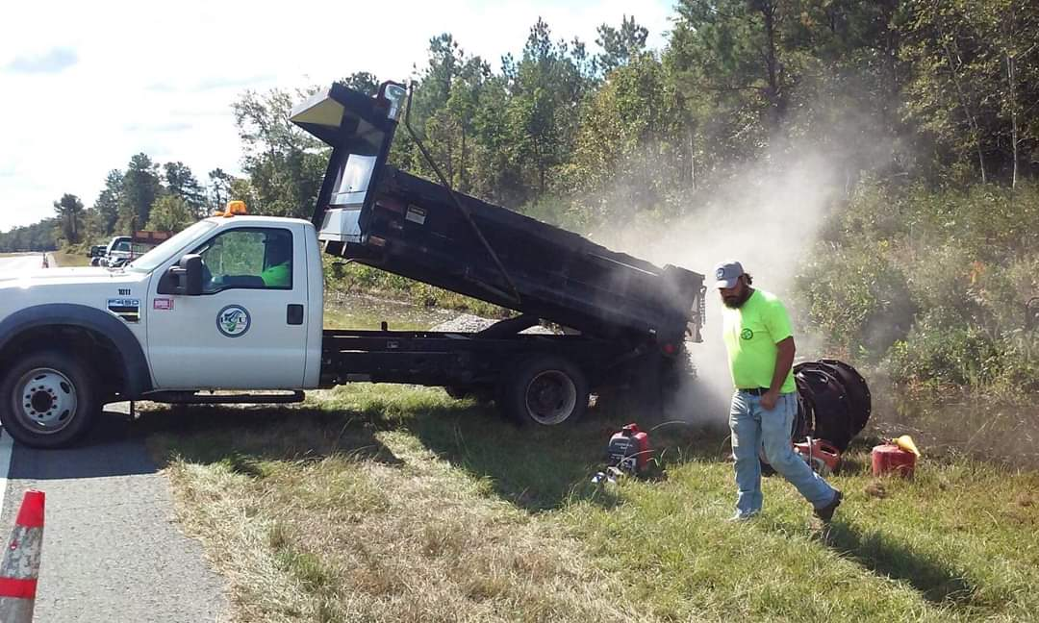



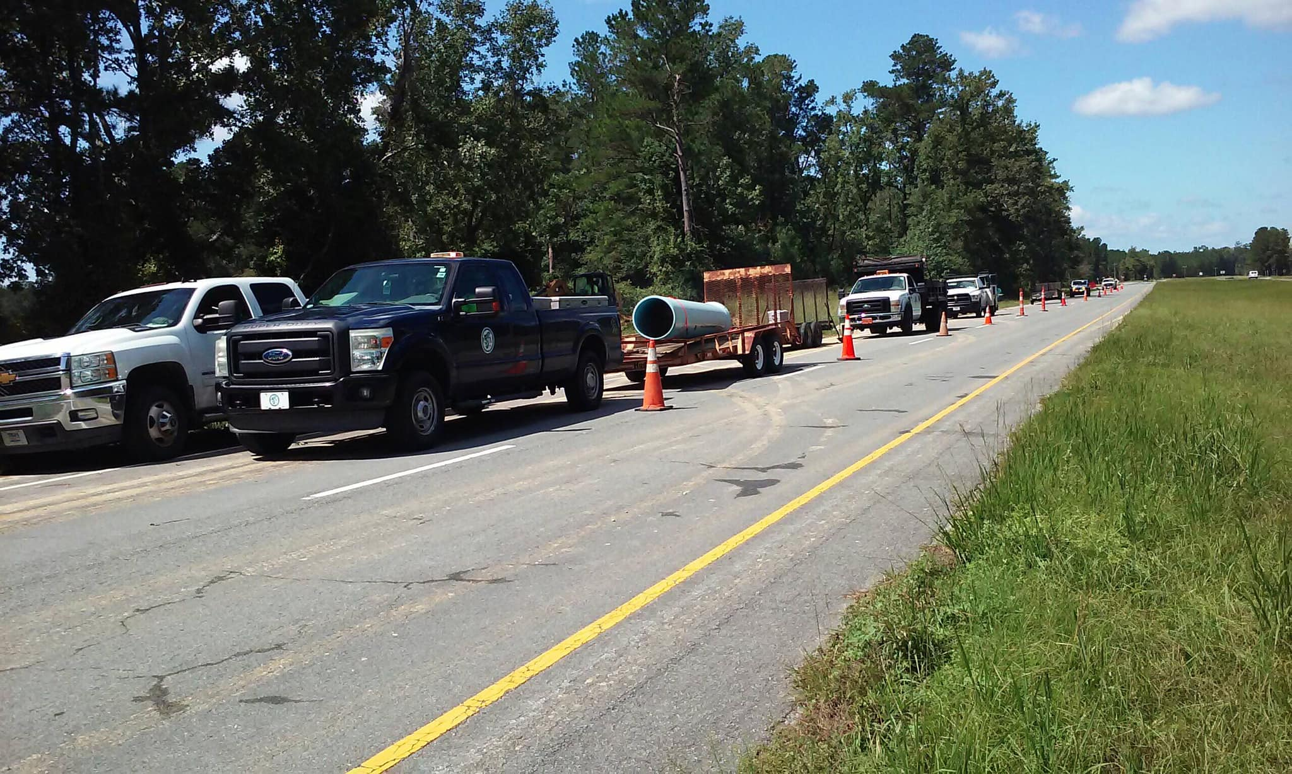

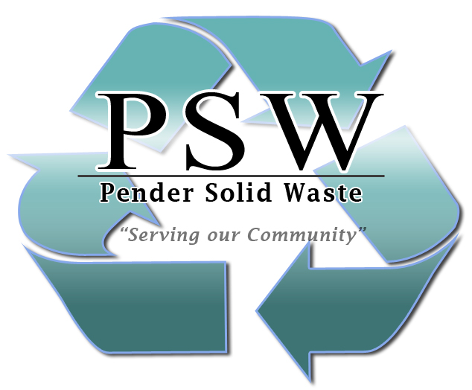

“Serving our Community”