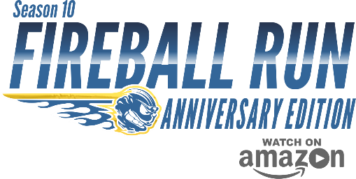
FOR IMMEDIATE RELEASE
Season 10 Fireball Run ‘Anniversary Edition’ Premieres on Amazon
Featuring Team 64 from Pender County Tourism
Feb. 2, 2018
SANTA FE, NM. – The much anticipated tenth season of the Fireball Run television series has premiered on Amazon Video. The 26-episode adventure-travel series traverses from Western New York to Massachusetts. Season 10, titled Anniversary Edition, spotlights the extraordinary history, sights, attractions, and people of under-discovered America while also aiding in the nation’s largest recovery effort for missing and exploited children.
Participating in season 10 series is local Tammy Proctor, Pender County Tourism director, and Carrie DeLeon as team number 64, Nun-Thing Wrong hailing from Pender County and Vero Beach, Florida respectively. They joined a cast of over 100 dashing to cities within the Northeastern United States. Fireball Run chronicles the adventurous journey of 40 driving teams as they receive several clues which if solved, lead to rare, historic, or epic experiences.
More than just great entertainment, since 2007 the series has leveraged its exposure to support Child Rescue Network, a 501-c3 charity in a Race To Recover America’s Missing Children. Each contestant team is assigned a child missing from their local region and provided posters featuring the child to distribute along the 2,000-mile, ten-day live production. The series has since aided in the successful recovery of 50 missing children.
Team 64 was assigned the case of Tiffany Warrington who was abducted on Sept. 26, 2001 from Florida. “Fireball Run partners with the Child Rescue Network to raise awareness of America’s missing children”, said DeLeon. Co-Driver Tammy Proctor added, “Fireball Run is an adventure series, but it is the race to find America’s missing children. In 2015, Pender County and Topsail Island hosted the Fireball Run series and it was an adventure we thoroughly enjoyed.”
Best described as a contest, history, and travel show combined, Fireball Run differs significantly from Reality TV. The Factual Entertainment series is filmed authentically in real-time, then edited into an exciting 26-episode series that entertains while educating viewers about amazing sites and attractions visited and experienced by show contestants.
No easy task; solving the clues often involves assistance from a strong support team of fans, family, friends. How well did local team Nun-Thing Wrong score? You’re in luck if you have an Amazon Prime account. The series is distributed by Amazon and bingeing is free for Prime members. If not, maybe it’s time to join. Alternately, you can just go to Amazon to buy, download and keep the entire season.

Media representatives can request clips, publicity stills, or schedule interviews using the info below.
Adrenaline Partnership LLC., M-F 9am-5pm MT (818) 572.1400 or media@fireballrun.com www.fireballrun.com
December 2017 the production relocated from Orlando to its own 22-acre Scaramanga Studio-Ranch in Santa Fe, NM.

