Interbasin Transfer Annual Report

Calendar Year 2020

Submitted by

Pender County Utilities

Prepared by: Amy Cox, Utilities Analyst

Pender County Utilities

Committed to Quality

February 2021

*This document has been prepared in accordance with the Pender County’s Water Systems’ October 2018 Interbasin Transfer Certificate*



TABLE OF CONTENTS

Executive Summary 1

System Overview 1

2020 Monthly Average Transferred Table 1 2

Acronyms and Abbreviations 2

1. Introduction 3
2. IBT Monitoring 4
   1. Water Conservation Plan- Condition 1 4
   2. Drought Management Plan – Condition 2 5
   3. Compliance and Monitoring Plan – Condition 3 6
   4. Availability of Alternative Water Source – Condition 4 6
   5. Amendment of Authorized IBT Amount – Condition 5 7
   6. Reselling of Water – Condition 6 7
   7. Limitations of Certificate – Condition 7 7
3. Appendix A (2018 IBT Summary) 8
4. Appendix B (2019 IBT Summary) 9
5. Appendix C (2020 IBT Summary) 10
6. Appendix D (PCU Commercial Sewer Collection System Schematic) 11

**Executive Summary**

The 2020 Interbasin Transfer (IBT) Annual Report for Pender County Utilities (PCU) includes monitoring data for monthly IBT tracking amounts and evidence of compliance with all IBT certificate conditions.

The October 2018 IBT certificate was authorized by the North Carolina Environmental Management Commission (NC EMC) to transfer up to 14.5 million gallons per day (MGD) from the Cape Fear River IBT basin. The IBT Certificate requires Pender County Utilities to report the Monthly Average IBT results quarterly and annually to the North Carolina Division of Water Resources (NC DWR). If the IBT amount transferred exceeds 80% of the authorized amount, which would be 11.6 MGD then Pender County Utilities will be required to report monthly. The water that is transferred from the Cape Fear River IBT basin is accounted for based on where the water is consumed or discharged. Water must flow through the Northeast Cape Fear River basin to reach customers in the New River Basin, is accounted for as a transfer from the Cape Fear River Basin to the New River Basin. The small amount of consumptive use that occurs in the Cape Fear River Basin does not constitute IBT.

**SYSTEM OVERVIEW**

Pender County Utilities currently owns and operates a 2 MGD water treatment plant (WTP) that treats surface water from the Cape Fear River. PCU obtains its raw water supply from the Cape Fear River via the Lower Cape Fear Water & Sewer Authority (LCFWASA) and has a Water Supply Agreement with LCFWASA. The contract includes the following clause “LCFWASA will deliver raw water to the County in an amount sufficient to meet the County’s raw water needs from the Authority, which currently does not exceed 6 MGD.”

The LCFWASA intake and associated Kings Bluff Raw Water Pumping Station are located just above Lock and Dam 1 on the Cape Fear River. LCFWASA transmits raw water via its existing 48 inch transmission main (54 inch diameter future transmission main) to PCU’s WTP, which is also located within the Cape Fear River Basin.

PCU’s WTP is presently treating approximately 2 MGD. Table 1 below details the Monthly Average Transferred Water in 2020 from the WTP. The facility is readily expandable to 6 MGD. The system’s process water used at the WTP is treated and returned to the Cape Fear River.

The US 421 Wastewater Treatment Plant (WWTP) is owned and operated by PCU. The WWTP is permitted for 0.5 MGD. The plant directly discharges to the Cape Fear River Basin.

A manifold force main system and pump stations serve approximately 20 commercial and institutional customers in the Rocky Point / Topsail Water Sewer District. This system ultimately can convey up to 0.25 MGD to the neighboring Cape Fear Public Utility Authority (CFPUA) in New Hanover County for treatment. Our records indicate that an average daily flow of 36,000 gallons of sewer is transferred to CFPUA daily. There is the potential to expand capacity with CFPUA, if they have available capacity at the time it is needed. CFPUA provides treatment at its Northside WWTP, which discharges to the Cape Fear River downstream of the confluence with the Northeast Cape Fear River.

Page 1

**Table 1**

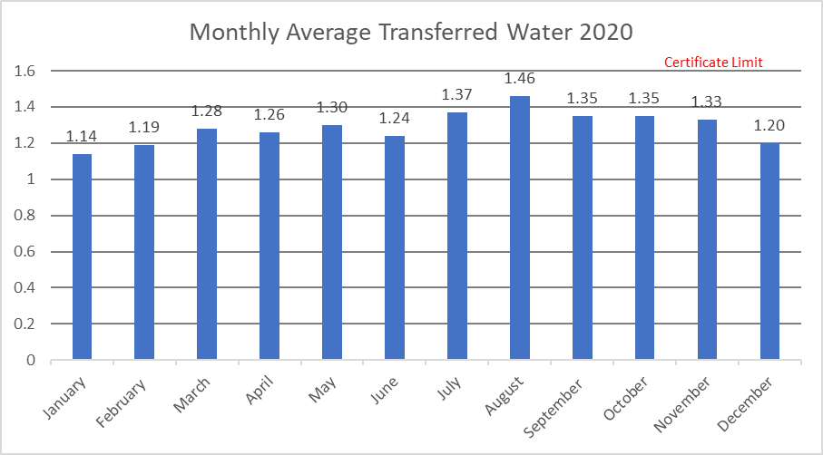

Acronyms and Abbreviations

CIY Pender County’s Connect (Reverse 911) System

EA Environmental Assessment

IBT Interbasin Transfer

LCFWASA Lower Cape Fear Water & Sewer Authority

MGD Million Gallons per Day

NCDWR North Carolina Division of Water Resources

NCEMC North Carolina Environmental Management Commission

NCGS North Carolina General Statues

PARTNERS The Towns of Burgaw, Topsail Beach, Surf City, and Wallace, as well as Utilities Inc, (for water service to the Belvedere Plantation and Olde Pointe Developments)

PCU Pender County Utilities

US 421 US Highway 421

WTP Water Treatment Plant

WWTP Wastewater Treatment Plant

Page 2

1.0 Introduction

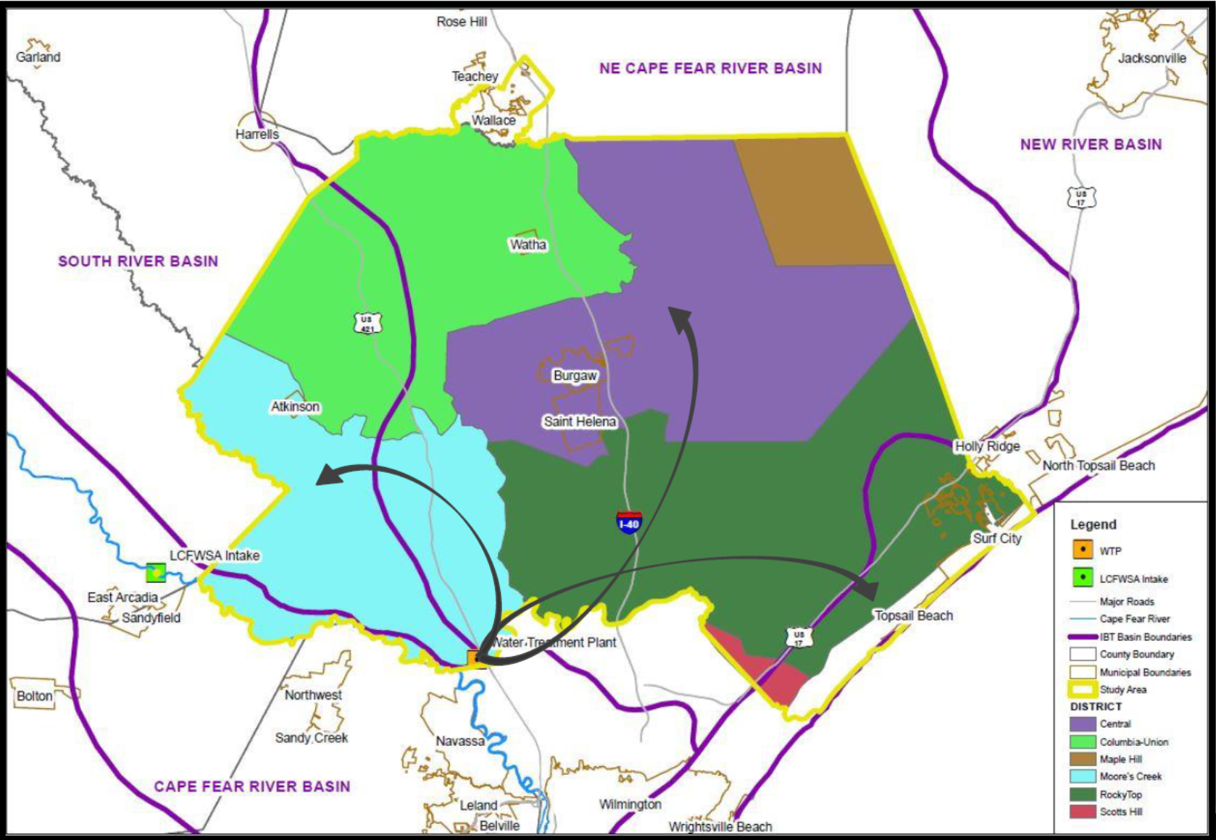

Pender County Utilities has received an interbasin transfer (IBT) signed into effect on October 19, 2018. The North Carolina Environmental Management Commission NCEMC has authorized transfers of up to 14.5 million gallons per day (MGD) from the Cape Fear River Basin to the South River IBT Basin, Northeast Cape Fear River IBT Basin, and the New River IBT Basin. The IBT certificate for PCU states that an Annual Report that documents transfers over the past year is required.

PCU’s Surface Water Treatment Plant provides water to five water districts shown on the map above. The districts include: Rocky Point / Topsail, Scotts Hill, Central Pender, Moore’s Creek, and Columbia-Union. Pender County also has the ability to acquire water from the partners: Town of Wallace and Town of Surf City. On an emergency only basis water can be obtained from: Belvedere (Utilities, Inc.), Topsail Beach, and Town of Burgaw.

Page 3

2.0 IBT Monitoring

The table below summarizes actual IBT amounts for calendar years 2018 to 2020. The table accounts the daily amounts of water transferred from the Cape Fear River Basin to Pender County customers that is not returned to the Cape Fear River Basin.



2.1 Water Conservation Plan – Condition 1

*Within 90 days of receipt of the IBT Certificate, Pender County Utilities shall prepare and submit a water conservation plan subject to approval by the NCDWR that specifies the water conservation measures, including a rate pricing structure, to be implemented by PCU in the receiving river basin to ensure the efficient use of the transferred water. PCU submitted a water conservation plan for review April 6, 2017, which was approved by the NCDWR effective November 30, 2017 and distributed for a 30-day public review via the State Environmental Clearinghouse on December 8, 2017. Except in circumstances of technical or economic infeasibility or adverse environmental impact, the water conservation plan shall provide for the mandatory implementation of water conservation measures by PCU that equal or exceed the most stringent water conservation plan implemented by a public water system that withdraws water from the source river basin. The towns of Burgaw, Topsail Beach, Surf City and Wallace as well as Utilities, Inc.(for water service to the Belvedere Plantation and Olde Pointe developments), identified as co-applicants on this IBT Certificate, shall implement water conservation plans at least as stringent as the requirements imposed on Pender County in order to receive any surface water transferred under this certificate. PCU shall not transfer any water to any other unity of local government beyond those listed in the Certificate, unless approved by the NCEMC. All units of local government receiving any transferred water originating from the Cape Fear River IBT basin by the Applicants are bound by this condition in full.*

The Water Conservation Plan was submitted within 90 days to NCDWR and is available on both the NCDEQ website (<https://deq.nc.gov/node/83243>) and the Pender County Website ([http://www.pendercountync.gov/utl/](http://www.pendercountync.gov/utl/water-conservation-tips/)documents-base/)

In 2020, PCU created education materials for customers on conserving water by many different avenues. Conservation information can be obtained by PCU’s website, flyers in water bills, and by the County’s Connect – CIY (reverse 911) System.

Page 4

2.2 Drought Management Plan – Condition 2

*Within 90 days of receipt of the IBT Certificate, PCU shall prepare and submit a drought management plan subject to approval by the NCDWR that specifies how the transfer shall be managed to protect the source river basin (Cape Fear River IBT basin) during drought conditions or other emergencies that occur within the source river basin. PCU submitted a drought management plan for review April 6, 2017, which was approved by the NCDWR effective November 30, 2017 and distributed for a 30-day public review via the State Environmental Clearinghouse on December 8, 2017. Except in circumstances of technical or economic infeasibility or adverse environmental impact, this drought management plan shall include mandatory reductions in the permitted amount of the transfer based on the severity and duration of a drought occurring within the source river basin. All co-applicants to this IBT Certificate shall implement a drought management plan at least as stringent as the requirements imposed on Pender County. PCU shall not transfer any water to any other unit of local government unless that unit of local government agrees to be bound by this condition in full*.

During 2020, the Drought Management Steps were not initiated due to sufficient water levels in the Cape Fear River Basin. Throughout the year the WTP retained normal operations using 2 MGD or less from the Cape Fear River IBT Basin.

Page 5

2.3 Compliance & Monitoring Plan – Conditon 3

*Within 90 days of receipt of the IBT Certificate, PCU shall submit a quarterly compliance and monitoring plan subject to approval by the NCDWR. The plan shall include methodologies and reporting schedules for reporting the following information: daily transfer amount calculated as the average daily over the maximum month, compliance with certificate conditions, progress on mitigation measures, drought management, and reporting. A copy of the approved plan shall be kept on file with the NCDWR for public inspection. The NCDWR shall have the authority to make modifications to the compliance and monitoring plan as necessary to assess compliance with the certificate. The NCDWR will monitor the transfer from the Cape Fear River IBT basin to the South River, Northeast Cape Fear River, and New River IBT basins, as regulated by the IBT certificate. The quarterly compliance and monitoring report shall be submitted to the Commission no later than 30 days after the end of the quarter. PCU shall employ any methods or install and operate any devices required to measure the amount of water that is transferred during each calendar quarter, calculated as a daily average of a calendar month.*

The Compliance and Monitoring Plan was submitted within 90 days to NCDWR and is available on both the NCDEQ website: (<https://deq.nc.gov/node/83243>) and the Pender County Website: ([http://www.pendercountync.gov/utl/](http://www.pendercountync.gov/utl/water-conservation-tips/)documents-base)

At the end of each quarter, PCU calculated the monthly average IBT amount for each month in the quarter and submitted a brief summary to NCDWR. PCU also posted this information on its website ([http://www.pendercountync.gov/utl/](http://www.pendercountync.gov/utl/water-conservation-tips/)documents-base). The annual report to NCDWR was submitted February 17, 2021 via email.

2.4 Availability of Alternative Water Source – Conditon 4

*The Commission may amend the certificate to reduce the maximum amount of water authorized to be transferred whenever it appears that an alternative source of water is available to the certificate holder from within the receiving river basins, including, but not limited to, the purchase of water from another water supplier within the receiving basins or to the transfer of water from another sub-basin within the receiving major river basin.*

This condition requires no action by the Partners.

Page 6

2.5 Amendment of Authorized IBT Amount – Conditon 5

*The commission shall amend the certificate to reduce the maximum amount of water authorized to be transferred if the Commission finds that PCU’s current projected water needs are significantly less than projected water needs at the time the certificate was granted.*

This condition requires no action by the Partners.

2.6 Reselling of Water – Conditon 6

*PCU will not resell the water that would be transferred pursuant to the certificate to another public water system. This limitation shall not apply in the case of a proposed resale or transfer among public water systems within the receiving river basin as part of an inter-local agreement or other regional water supply arrangement, provided that each participant in the inter-local agreement or regional water supply arrangement is a co-applicant for the certificate and will be subject to all the terms, conditions, and limitations made applicable to any lead or primary applicant. The Towns of Burgaw, Topsail Beach, Surf City, and Wallace as well as Utilities, Inc. (for water service to the Belvedere Plantation and Olde Pointe developments) are co-applicants to this IBT certificate.*

This condition requires no action by the Partners.

2.7 Limitation of Certificate – Conditon 7

*The commission may reopen and modify or revoke this Certificate to ensure continued compliance with N.C.G.S. Chapter 143, Article 21, Part 2A.*

This condition requires no action by the Partners

Page 7

3.0 2018 IBT Summary – Appendex A

Page 8















Page 9













5.0 2020 IBT Summary – Appendex C

Page 10













6.0 Collection System Schematic – Appendex D

Page 11

